**PROJECT REPORT**

**ST.JOHN’S COLLEGE – PALAYAMKOTTAI**

**DEPARTMENT OF PHYSICS**

**Uncovering the Gaming Industry's Hidden Gems: A Comprehensive Analysis of Video Game Sales**

**TEAM MEMBERS**

**1.bina caroline**

**2.Bindhuja**

**3.bijin zerubal**

**4.appadurai**

**Uncovering the Gaming Industry's Hidden Gems: A Comprehensive Analysis of Video Game Sales**

**Introduction**

The gaming industry is exponentially expanding touching everyone's lives daily without even realizing it. Millions of games have been released and are now readily available for us to play from our living room to our social media on our phone. Working in this industry is truly fascinating. Working in a truly global company with offices around the world is even more fascinating. I will share with you my knowledge on gaming, discuss its future and teach you best practises in working with teams of different cultures.

## DESCRIPTION

## Video game sales analysis is the process of collecting and analyzing data about the sales of video games in order to understand market trends and consumer behavior. This type of analysis can be useful for a variety of purposes, including identifying the most popular games and genres, predicting future sales, and developing marketing strategies.Video game sales analysis typically involves collecting data from Kaggle sources. It was generated by a scrape of vgchartz.com. This data may include information about the number of units sold, the retail price, and the platforms on which the games are played. Once the data has been collected, it is typically analyzed using tableau. The results of the analysis can be used to identify trends and patterns in the market, and to make informed decisions about the development and marketing of video games.Video game sales analysis may be conducted by game developers, publishers, retailers, and other industry professionals. It is an important part of the video game industry, as it helps to understand the needs and preferences of consumers and to identify opportunities for growth and innovation. Analysing sales data from more than 16,500 games. This dataset contains a list of video games with sales greater than 100,000 copies.It was generated by a scrape of vgchartz.com.

OVERVIEW

PURPOSE

## The video game industry encompasses the development, marketing, and monetization of video games. The industry encompasses dozens of job disciplines and thousands of jobs worldwide.

MILESTONE 1 PROBLEM DEFINING

Problem is based on developing the game and to specify the business problem and business requirements

Empathy map

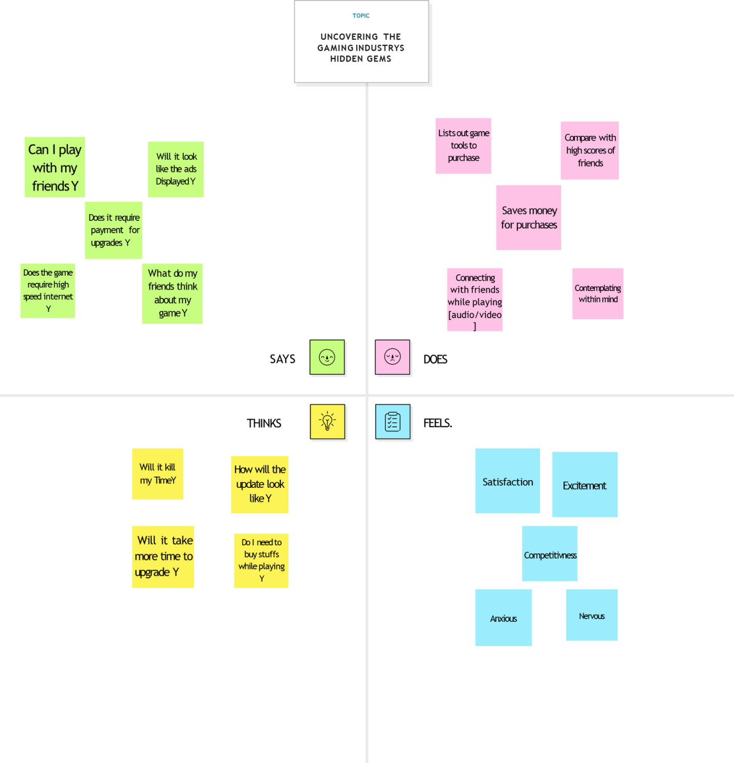

Brainstorming

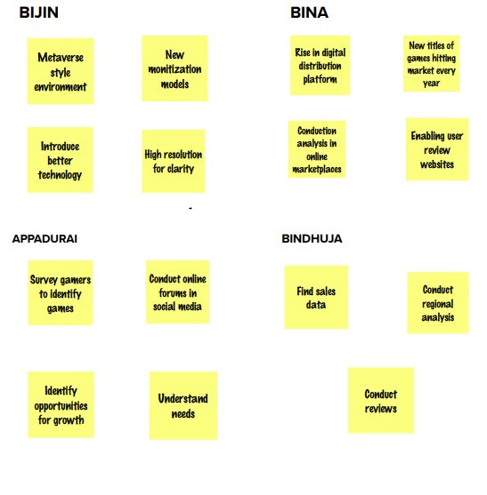

BRAINSTROMING GRAPH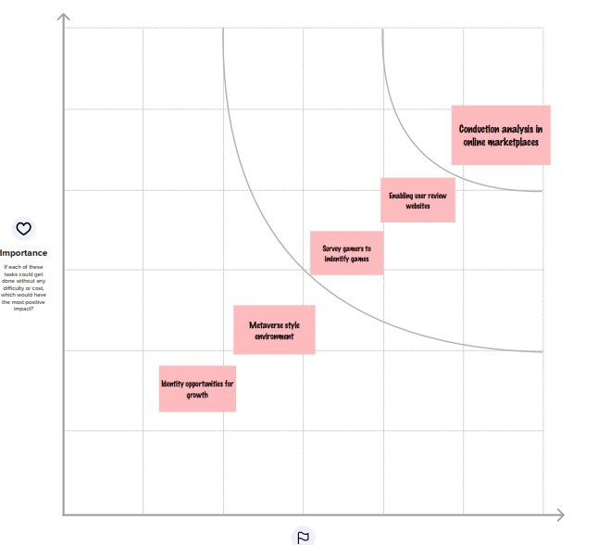

Result

Dashboard

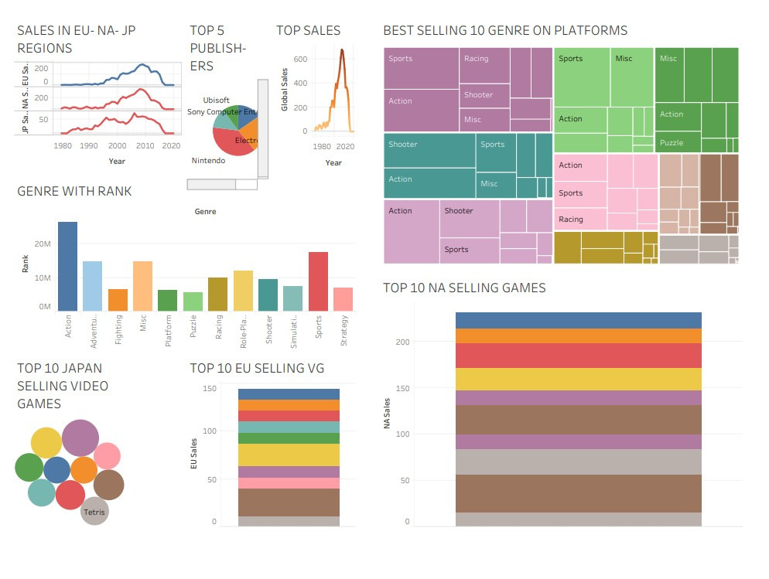

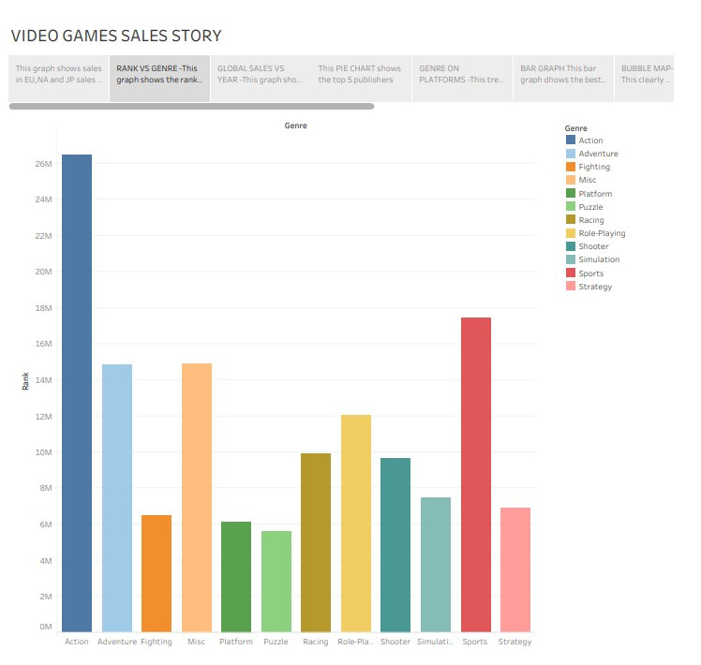

Story

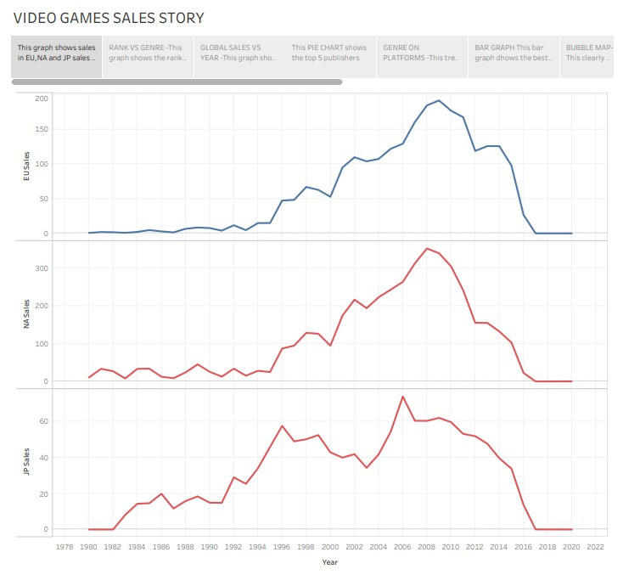

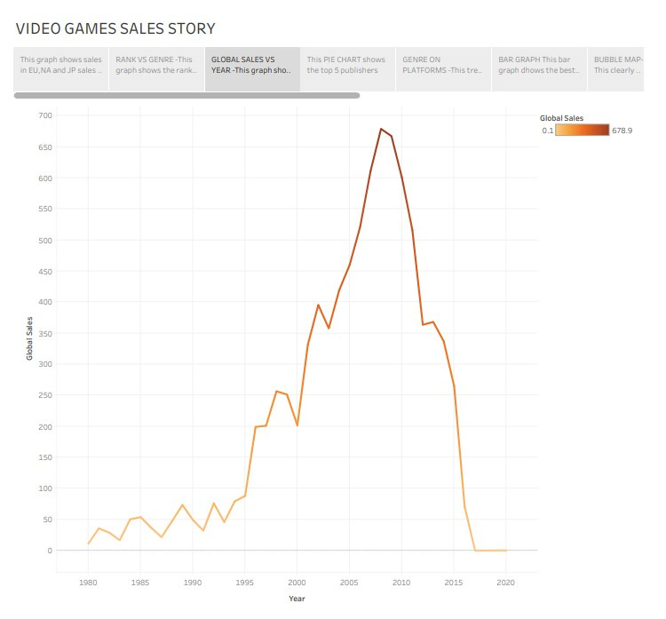

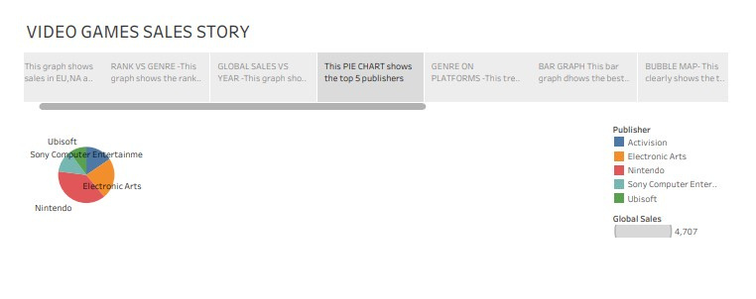

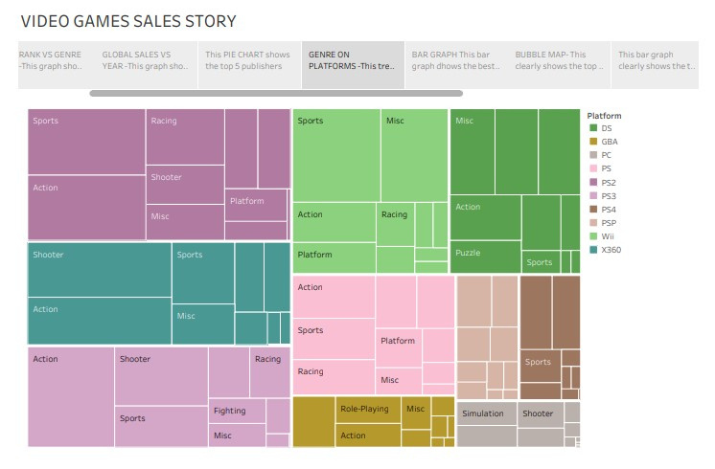

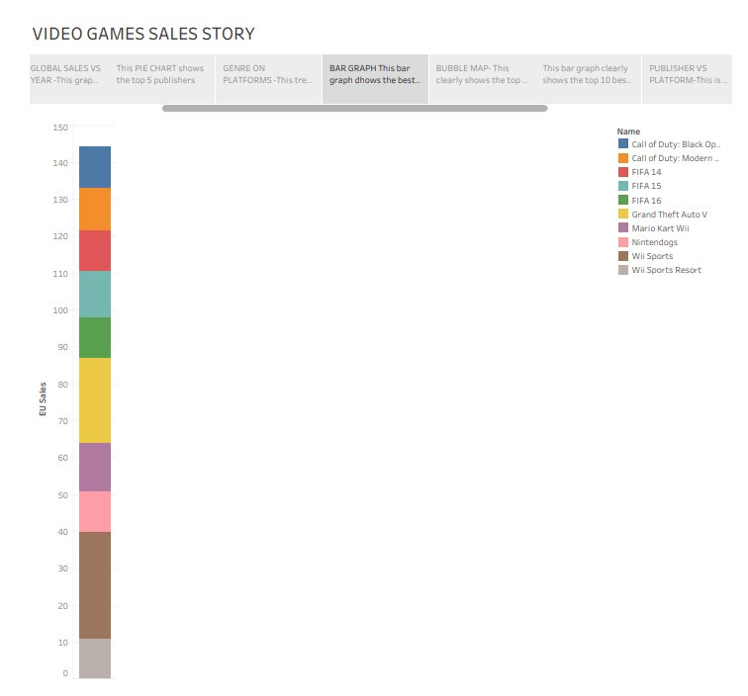

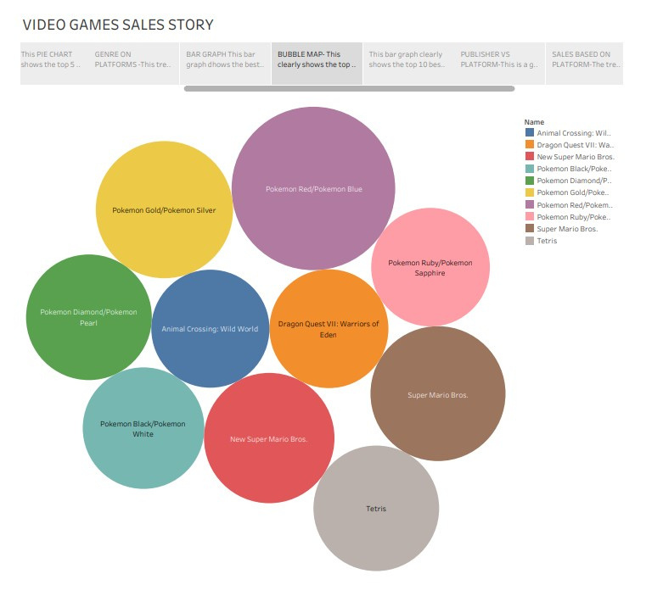

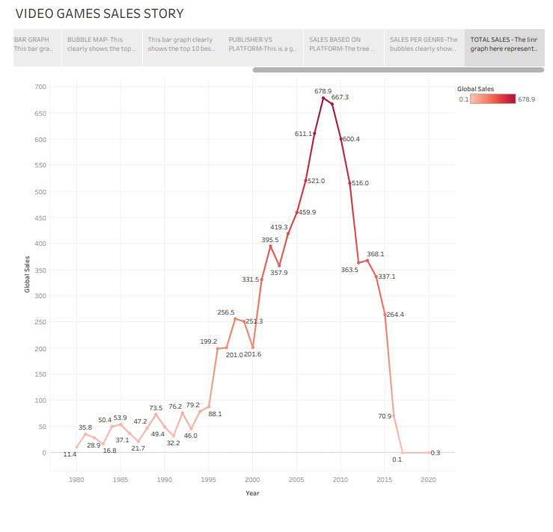

ADVANTAGE

The benefits of videogames have also reached education with game-based learning. **This teaching method uses beneficial aspects of videogames to transmit knowledge to students. It is based on three key factors:**

* **It breathes life into education:** it transforms learning into an enjoyable, thrilling game without boring lessons. Students assimilate and retain information almost without noticing.
* **It boosts motivation:** students are the main characters in the story and their success is rewarded with medals, extra lives, bonuses, etc. This captures and keeps their interest in learning.
* **It gives opportunities to practice:** students can apply the knowledge they acquire without getting into dangerous situations. This is what flight and navigation simulators, for instance, are all about.

DISADVANTAGE

Spending excessive time on online games can lead to physical health issues, such as poor posture, carpal tunnel syndrome, headaches, and eye strain. Additionally, it can also lead to poor mental health, including anxiety disorders and depression.

APPLICATION

* Increased Role of Mobile Phones. Smartphones are a necessity now for people and they are everyday evolving in their capacities and potential. ...
* Making Social Games. ...
* Gamifying Non Gaming Activities. ...
* Versatility of Games.

Conclusion

There are lots of efforts going into creating a single game and due to modern era mobile games other platforms are getting deprived of the attention which had created a lot of awesome experiences for gamers from 1980 - 2010

FUTURE SCOPE

Game Designing is one of the most upcoming Courses for students who wanted to make a Game Designer Career in India in animation. The gaming industry is rapidly growing at a pace of 50% per annum. There is a very wide and bright future in game design in India. Students can earn up to 3 Lakh to 5 Lakh PA.

Appendix

Source code

///C:/Users/Ram/Desktop/BINA/BizLand/indexx.html